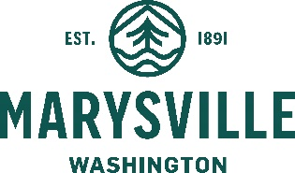
COMMUNITY DEVELOPMENT DEPARTMENT

501 Delta Avenue  Marysville, WA 98270

MEMORANDUM
DATE: January 4, 2023
TO: Planning Commission
FROM: Angela Gemmer, Principal Planner
SUBJECT: Public Notice Code Amendments
ECC: Haylie Miller, Community Development Director
Chris Holland, Planning Manager
Exhibit 1: Initial Memo Re. Public Notice Code Amendments
Exhibit 2: Public Notice Code Amendments

Attached are proposed amendments to the Marysville Municipal Code (MMC) pertaining to public notice provisions. This topic was first introduced to Planning Commission at the November 29, 2022 work shop (see attached Exhibit 1). The original intent of the code amendments was to eliminate notice provisions that are time-intensive, but not well-utilized by the public (e.g. posting at public buildings or on the local cable access channel). While drafting the amendments, additional areas where improvements could be made were identified. The additional amendments are generally to:
- Require notice on the City’s website;
- Better organize the code;
- Ensure that the code is internally consistent and, whenever possible, refer the reader to the general notice provisions in MMC Chapter 22G.010, Land Use Application Procedures, rather than having notice provisions dispersed in other chapters;
- Clarify the project types which require notice and ensure consistency of notice provisions in code with actual process; and
- Eliminate redundant or conflicting language.
At the Public Hearing on January 10, 2023, staff respectfully requests that the Planning Commission make a recommendation of approval of the proposed public notice code amendments to City Council for adoption by Ordinance.

