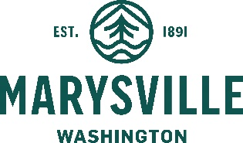
COMMUNITY DEVELOPMENT DEPARTMENT

501 Delta Avenue  Marysville, WA 98270

MEMORANDUM
DATE: January 31, 2023
TO: Planning Commission
FROM: Angela Gemmer, Principal Planner
SUBJECT: Public Notice Code Amendments
ECC: Haylie Miller, Community Development Director
Chris Holland, Planning Manager
Exhibit 1: Ordinance – Public Notice Code Amendments
Exhibit 2: PC Recommendation
Exhibit 3: PC Minutes – November 29, 2022
Exhibit 4: PC Minutes – January 10, 2023
The Marysville Municipal Code (MMC) outlines public notice requirements for land use applications. Some current notice requirements are time-intensive, but not well-utilized by the public (e.g. posting of individual notices at public buildings or on the local cable access channel) - Channel 21. The proposed amendments are primarily to remove the requirement to post notices for each individual project at public locations and to post certain land use projects on Channel 21. Instead, a standard notice would be posted at public locations directing the public to where information on land use projects can be obtained. This standard notice would include a QR code, the City's web address, and the Community Development Department phone number so the public can obtain additional information on projects. The QR code would take the public to a page where notices and project information is displayed.
Additional amendments are concurrently proposed which consist of:
- Requiring notice on the City’s website;
- Organizing the code better;
- Ensuring that the code is internally consistent and, whenever possible, referring the reader to the general notice provisions in MMC Chapter 22G.010, Land Use Application Procedures, rather than having notice provisions dispersed in other chapters;
- Clarifying the project types which require notice and ensuring consistency of notice provisions in code with actual process; and
- Eliminating redundant or conflicting language.
Staff respectfully requests that the City Council affirm the recommendation of the Planning Commission, and adopt the proposed public notice code amendments by Ordinance.

