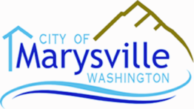
PLANNING COMMISSION AGENDA
City Hall – Council Chambers  1049 State Avenue  Marysville, WA 98270
Tuesday, September 24, 2019 – 7:00 PM
CALL TO ORDER:
- APPROVAL OF MINUTES (September 10, 2019)
- AUDIENCE PARTICIPATION (for topics not on the agenda)
- NEW BUSINESS
- PUBLIC HEARING – CODE AMENDMENTS
- MMC Section 22C.020.060, Permitted Uses – amendments requested by Puget Sound Regional Council (PSRC) for Light Industrial (LI) zoning within Cascade Industrial Center (CIC)
- MMC Chapter 22G.100, Binding Site Plan (BSP)
- MMC Chapter 22G.080, Planned Residential Development (PRD) amendments
- CITY COUNCIL AGENDA ITEMS and MINUTES
Council agenda items and minutes are available on the city website: www.marysvillewa.gov, or you can simply click on the following link:
Council Agenda Items and Minutes
- ADJOURNMENT
- NEXT MEETING – Tuesday, October 8, 2019 – 7:00 PM

