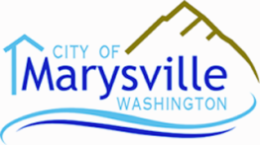
PLANNING COMMISSION AGENDA
City Hall – Council Chambers  1049 State Avenue  Marysville, WA 98270

Tuesday, May 24, 2016 7:00 PM
CALL TO ORDER:
- WELCOME NEW PC MEMBER (Brandon Whitaker)
- APPROVAL OF MINUTES (Tuesday, May 10, 2016)
- AUDIENCE PARTICIPATION (for topics not on the agenda)
- PUBLIC HEARING – Code Amendment – Marijuana Regulations
- NEW BUSINESS – Code Amendment – Plat and Short Plat Extensions
- CITY COUNCIL AGENDA ITEMS and MINUTES
Council agenda items and minutes are available on the city website: www.marysvillewa.gov, or you can simply click on the following link:
Council Agenda Items and Minutes
- ADJOURNMENT
- NEXT MEETING – June 14, 2016

