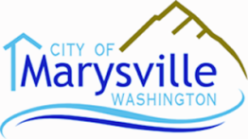
PLANNING COMMISSION AGENDA
City Hall – Council Chambers  1049 State Avenue  Marysville, WA 98270
Tuesday, December 9, 2014, 7:00 PM
CALL TO ORDER:
- APPROVAL OF MINUTES (Tuesday, November 25, 2014)
- AUDIENCE PARTICIPATION
- OLD BUSINESS
- PC Recommendations – Code Amendments (hearing closed) #1
- PUBLIC HEARING – Continued: TAB
- Geologic Hazards Code Amendment #2
- NEW BUSINESS
- 2015 Comprehensive Plan Amendment
- Economic Development Element #3
- Environmental Element #4
- CITY COUNCIL AGENDA ITEMS and MINUTES
Council agenda items and minutes are available on the city website: www.marysvillewa.gov, or you can simply click on the following link:
http://docs.marysvillewa.gov/htcomnet/Handlers/AnonymousDownload.ashx?folder=4dbbc379
- ADJOURNMENT
- NEXT MEETING – January 13, 2015
- 2015 Comp Plan Update
- Utilities Element
- Public Facilities and Services Element
- Capital Facilities Plan

