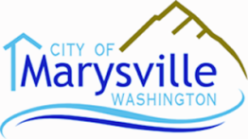
PLANNING COMMISSION AGENDA
City Hall – Council Chambers  1049 State Avenue  Marysville, WA 98270
July 8, 2014 7:00 PM

CALL TO ORDER:
- APPROVAL OF MINUTES
- April 8, 2014 TAB
- AUDIENCE PARTICIPATION:
- NEW BUSINESS:
- Non-Residential Uses in Residential Zones Signage #1
- Non-conforming Uses Code Amendment #2
- Caretaker’s Quarters Code Amendment #3
- Snohomish County and Cities Permit Statistics (PowerPoint) N/A
- OLD BUSINESS:
- Industrial Park Design Standards Photos (PowerPoint) N/A
- CITY COUNCIL AGENDA ITEMS and MINUTES
Council agenda items and minutes are available on the city website: www.marysvillewa.gov, or you can simply click on the following link:
http://docs.marysvillewa.gov/htcomnet/Handlers/AnonymousDownload.ashx?folder=4dbbc379
- ADJOURNMENT
- NEXT MEETING - July 22, 2014

